You’re cordially invited
to join top leaders and organizers for An unprecedented, unifying gathering of progressive leaders and activists working together for progress,
the first National Justice Roundtable
Monday, August 30th 1-5pm ET, 10am-2pm PT
Register for Zoom: https://actionnetwork.org/events/national-justice-roundtable/
RSVP/Media: Joel.R.Segal@gmail.com (571)-344-1518
Featured speakers and organizers:
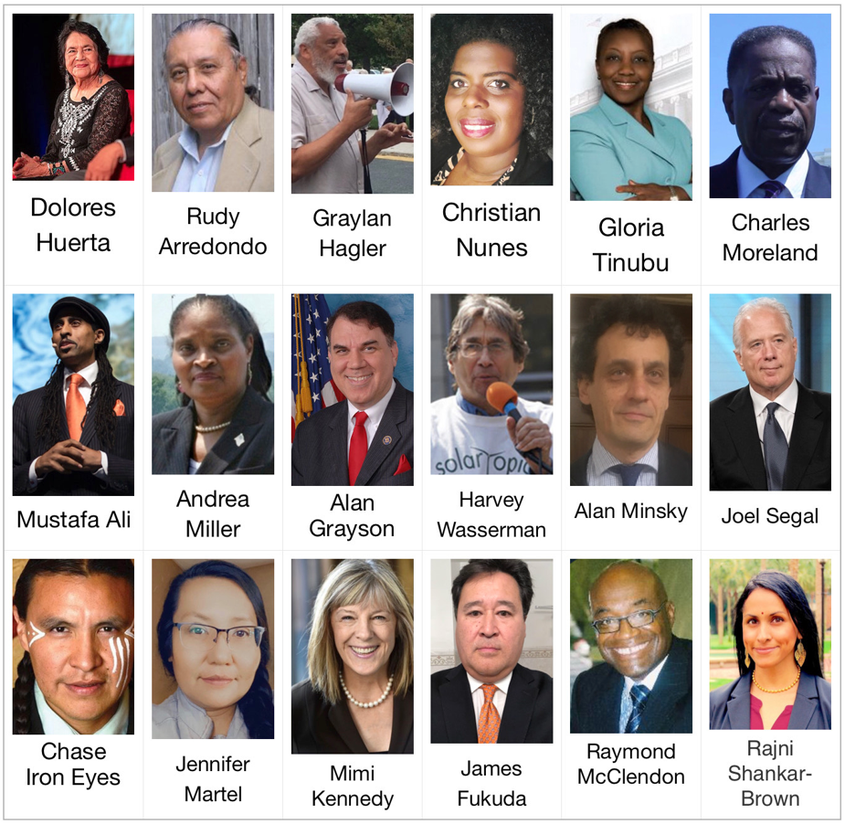
During this critical time, we must unite and organize in the streets and suites to
ensure that civilization will survive the climate, COVID, and other emergencies

We need your active participation in this series of National Justice Roundtables
Please join us August 30th for this historic round table meeting!

